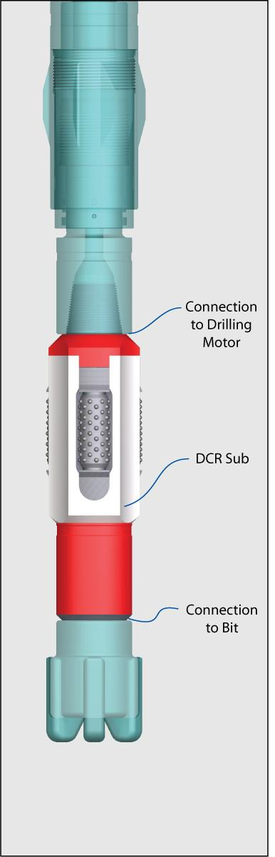
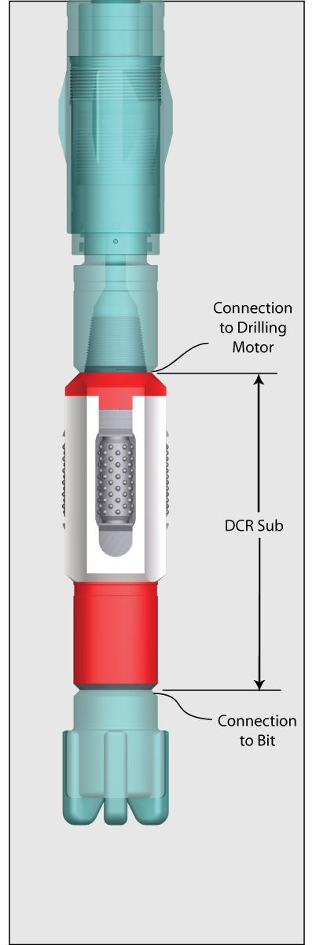
“Trendsetters in Downhole Drilling Solutions”

WZL

Deviation Control Reamer

Description

The Wenzel Downhole Deviation Control Reamer (DCR Sub) acts as a
near bit reamer/stabilizer. The three point sealed bearing cutters
maintain hole gauge and also function as a low torque stabilizer to
control hole deviation. The extremely short length of this sub is possible
due to the unique patented cutter retention method.

Features / Benefits

❍ Sealed and lubricated reamer cutters with internal bushings
provide the greatest durability in a near bit environment.
❍ Cutter pins are produced from hardened steel for long life.
❍ Cutter types; domed button or straight ridge.
❍ Replaceable thrust washers are installed at each end of the
cutters.
❍ Cutter blocks are precision machined to ensure correct gauge.
They are manufactured from alloy steel and finished hardened
for a superior combination of strength and wear resistance.
❍ No bolts or screws are used to retain the reamer blocks.

Deviation Control Reamer Specifications

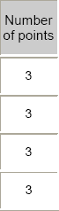
Imperial

Downhole Reaming
Motor Size Diameter
(inch) (inch)

Number
of points
Sub
Length
(feet)

Thru Bore
(inches)

Standard Bit
Box
Approximate
Weight
(lbs.)

6 1/2

6 1/2

6 1/2

8

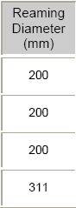
7 7/8

8 1/2

8 3/4

12 1/4

Metric

3

3

3

3

1.8

1.9

1.9

2.0

1.5

1.5

1.5

2.0
4 1/2 API
Regular
4 1/2 API
Regular
4 1/2 API
Regular
6 5/8 API
Regular

200

200

200

550

Downhole
Motor Size
(mm)

165

165

165

203
Reaming
Diameter
(mm)

200

200

200

311

Number
of points

3

3

3

3
Sub
Length
(m)

.56

.57

.57

.62

Thru Bore
(mm)

38

38

38

51

Standard Bit
Box

4 1/2 API
Regular
4 1/2 API
Regular
4 1/2 API
Regular
6 5/8 API
Regular
Approximate
Weight
(kg)

90

90

90

250

Specifications are based on as new condition and are subject to change without notice.

Wenzel Downhole Tools Ltd.

