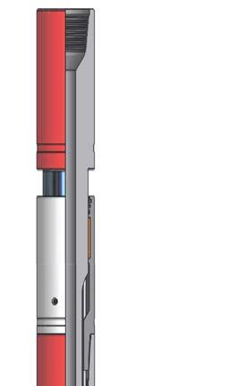
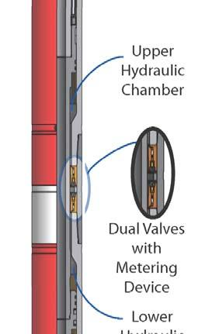
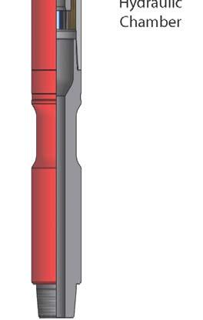
“Trendsetters in Downhole Drilling Solutions”

WZL

Double Acting Hydraulic Drilling Jar (HJDA)

Description

The Wenzel Downhole Double Acting Hydraulic Drilling Jar (HJDA) is a bi-directional
drilling jar incorporating hydraulic delay without a latch mechanism. This jar will allow
the operator to apply variable impact in both the up and down directions. The HJDA
is intended for use in highly deviated or high friction wells, where conditions may
prevent applying sufficient force to release a mechanical latch.

Features / Benefits

The Wenzel Downhole HJDA is hydraulically controlled and jars in both directions,
with impact force controlled by the operator.

Impact force is controlled by a metering device that ensures consistent delay times
over the full range of operating temperatures.

The HJDA operates via a simple up and down motion and is unaffected by right- or
left-hand torque.

Standard seals are suitable for use up to 275°F (135°C). Optional high temperature
seal kits are available suitable for service to 450°F (230°C). External sealing surfaces
are tungsten carbide-coated to enhance wear and corrosion resistance.

Operation
Jarring Up
• With the jar in the neutral position, apply the desired overpull in excess of the
free string weight, starting the hydraulic delay sequence. At the end of the
hydraulic delay, the jar will release causing an upward impact force.
• If necessary, lower the drill string sufficiently to close the jar to the neutral
position, ready to jar up again.
Jarring Down
• With the jar in the neutral position, lower the drill string to apply the desired
down force, starting the hydraulic delay sequence. At the end of the hydraulic
delay, the jar will release causing a downward impact force.
• If necessary, raise the drill string sufficiently to open the jar to the neutral
position, ready to jar down again.
Handling
• To prevent unintentional tripping during handling, the HJDA is fitted with a
safety clamp to keep the jar in the fully extended position. The safety clamp
must remain installed until the jar is ready to run into the hole.
• When preparing to run into the hole, connect the jar to the drill string and
apply tension before removing the safety clamp
• When coming out of the hole, install the safety clamp while the jar is still
under tension and fully extended.

Double Acting Hydraulic Jar (HJDA) Specifications – Standard

Imperial

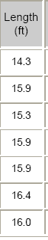
Nominal
OD
(inch)
3.38

4.25

4.75

6.25

6.75

8.00

Length
(ft)

14.3

15.9

15.3

15.9

15.9

16.4

Thru Bore
(inch)

1.50

2.00

2.25

2.25

2.75

2.81
Tensile
Yield
(lbs)
234,900

300,800

370,600

938,900

1,195,100

1,293,900
Torsional
Yield
(ft lbs)
6900

13,800

18,200

42,700

44,000

82,300
Max Pull
During Delay
(lbs)
50,000

70,000

85,000

160,000

190,000

240,000
Up
Stroke
(inches)
7

8

8

8

8

8
Down
Stroke
(inches)
7

8

8

8

8

8
Total
Stroke
(inches)
21

25

25

25

25

25
Estimated
Weight
(lbs)
280

490

590

1210

1350

2060

9.50

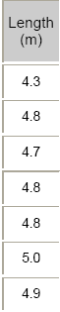
Metric

16.0

3.00

2,106,900 151,000

300,000

8

8

25
2780

Nominal
OD
(mm)
86

108

121

159

171

203

241

Length
(m)

4.3

4.8

4.7

4.8

4.8

5.0

4.9

Thru Bore
(mm)

38.1

50.8

57.2

57.2

68.9

71.4

76.2
Tensile
Yield
(daN)
104 500

133 800

164 800

417 600

531 600

575 500

937 200
Torsional
Yield
(N·m)
9400

18 700

24 600

57 900

59 700

111 600

204 700
Max Pull
During Delay
(daN)
22 200

31 100

37 800

71 200

84 500

106 800

133 400
Up
Stroke
(mm)
178

203

203

203

203

203

203
Down
Stroke
(mm)
178

203

203

203

203

203

203
Total
Stroke
(mm)
533

635

635

635

635

635

635
Estimated
Weight
(kg)
130

220

270

550

610

930

1260

Specifications are based on as new condition and are subject to change without notice.

(Tools are designed to be easily transportable by truck. Flex subs are available to ensure proper length for racking
operations.)

Wenzel Downhole Tools Ltd.

