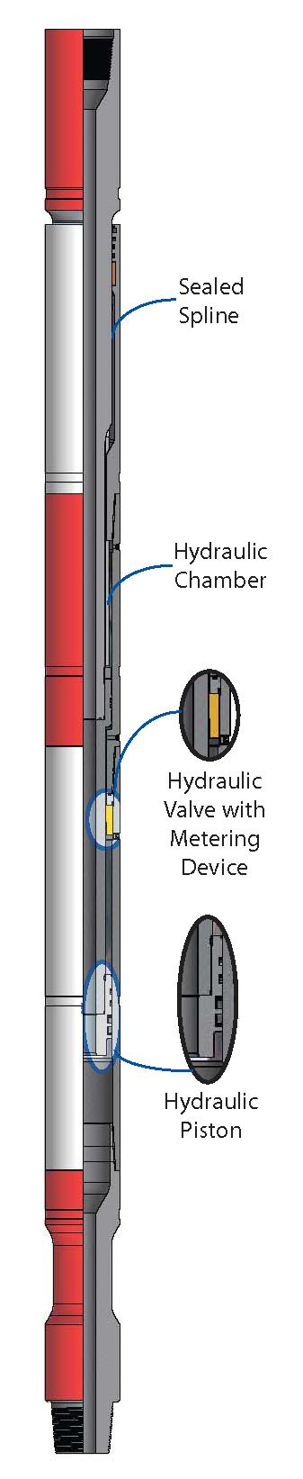
“Trendsetters in Downhole Drilling Solutions”

WZL

Hydraulic Fishing Jar (HJ)

Description

The Wenzel Downhole Hydraulic Jar (HJ) is designed primarily for fishing
applications. It jars in the upward direction only. Hydraulically operated, with impact
force controlled by the operator, the HJ is ideally suited for fishing, coring, milling or
other downhole applications.

Features / Benefits

• Delay time is controlled by a metering device, which provides uniform hydraulic
delay over a wide range of operating temperatures even after extended periods of
repeated jarring.

• A long splined mandrel ensures the jar is not affected by torsional forces. These
splines are sealed and lubricated to minimize friction and provide long wear life.

• While this jar is designed to be rugged enough for drilling applications, it is
intended for fishing, coring, and milling applications.

• A free stroke of 4” to 6” (depending on tool size) provides an impact force to the
stuck point several times higher than the overpull force applied to the jar.
•
Standard seals in the tool are effective to 275°F (135°C). The jar can be
dressed with seals effective to 450°F (230°C) for hot hole environments.

Operation (Jarring Up)

❍ HJ is activated by applying upward pull from the closed position.
❍ The amount of upward impact force can be changed by varying the amount
of overpull applied at surface.
❍ When upward overpull has been applied, the jar will fire after a timed delay.
The delay is reduced as upward force is increased.
❍ After the jar strikes an upward blow, re-setting is quickly accomplished by
lowering the drillstring until the jar is in the closed position.

Hydraulic Fishing Jar (HJ) Specifications

Imperial

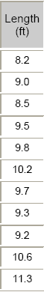
Nominal
OD
(inch)
3.12
3.38
3.75
4.25
4.75
5.00
6.25
6.50
7.75
8.00

Length
(ft)

8.2
9.0
8.5
9.5
9.8
10.2
9.7
9.3
9.2
10.6

Thru Bore
(inch)

1.00
1.50
1.25
2.00
2.25
2.25
2.25
2.25
3.00
3.00
Tensile
Yield
(lbs)
204,000
234,000
176,790
300,800
351,900
351,900
868,100
868,100
900,000
900,000
Torsional
Yield
(ft lbs)
660
7400
9100
13,800
16,100
23,300
35,000
44,000
79,600
86,900
Max Pull
During Delay
(lbs)
41,000
50,000
60,000
70,000
75,000
85,000
130,000
150,000
220,000
240,000

Free Stroke
(inches)

6.7
3.8
4.0
3.8
6.3
6.3
6.3
6.3
6.6
6.6

Total Stroke
(inches)

11
8.6
8
8.6
11
11
11
11
11
11

9.00

Metric
11.3
3.00
1,287,900 128,800
270,000
6.1
10.5

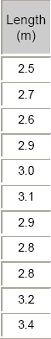
Nominal
OD
(mm)
79
86
95
108
121
127
159
165
197
203
229

Length
(m)

2.5
2.7
2.6
2.9
3.0
3.1
2.9
2.8
2.8
3.2
3.4

Thru Bore
(mm)

25.4
38.1
31.8
50.8
57.2
57.2
57.2
57.2
76.2
76.2
76.2
Tensile
Yield
(daN)
90 700
104 500
78 600
133 800
156 500
156 500
386 100
386 100
400 300
400 300
572 800
Torsional
Yield
(N·m)
8900
10 000
12 300
18 700
21 800
31 500
47 500
59 600
107 900
117 800
174 700
Max Pull
During Delay
(daN)
18 200
22 200
26 700
31 100
33 400
37 800
57 800
66 700
97 900
106 700
120 100

Free Stroke
(mm)

170
96
102
97
160
160
159
159
168
168
154

Total Stroke
(mm)

279
217
203
217
281
281
279
279
279
279
267

Specifications are based on as new condition and are subject to change without notice.

Wenzel Downhole Tools Ltd.

