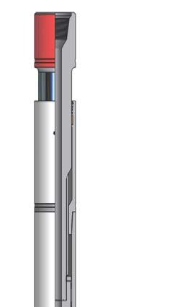
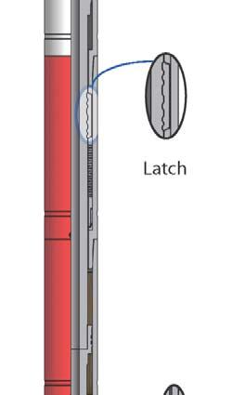
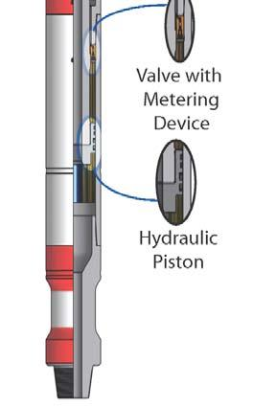
“Trendsetters in Downhole Drilling Solutions”

WZL

Hydraulic / Mechanical Drilling Jar (HMJ)

Description
The Wenzel Downhole Hydraulic / Mechanical Drilling Jar (HMJ) is a double acting jar,
designed to deliver hydraulic delay when jarring in the up direction, and mechanical
release when jarring in the down direction. The HMJ incorporates a latch mechanism
to keep the jar locked in the neutral position and eliminate unexpected jarring while
tripping or racking back in the derrick.

Features / Benefits
• The HMJ is normally operated in the latched position to reduce unexpected jarring
while drilling, and eliminate movement between jar components to increase service
life.

• The HMJ operates with a simple up and down motion and is not affected by torque.

• The spline drive and latch mechanism are enclosed in a single, sealed oil chamber
without ports that might fill with cuttings and restrict the down jar stroke.

• The hydraulic delay mechanism is located in a separate chamber to prevent
contamination and increase reliability.

• With the latch mechanism in the cocked or latched position, the inner mandrel and
outer housing act integrally, virtually eliminating seal and inner tool wear during
normal drilling conditions. There is no need to extend or open the jar before
running in the hole.

• Standard seals in the tool are effective to 275°F (135°C). The jar can be dressed
with seals effective to 450°F (230°C) for hot hole environments. External sealing
surfaces are tungsten carbide-coated to enhance wear and corrosion resistance.

• The HMJ can be run in tension or in compression within the preset latch settings.

Operation
(Jarring Up)
❍ Jarring up is achieved by applying sufficient overpull to overcome the latch
setting, which initiates the hydraulic time delay. During the time delay, the
overpull at surface can be adjusted to vary the impact force.
❍ After impact, apply a down force sufficient to close jar and re-engage latch,
then repeat the jarring cycle as required.

(Jarring Down)
❍ Jarring down is achieved by applying sufficient downward force to overcome
the latch setting and pump open force. At that point, the HMJ will release and
jar downward.
❍ After impact, pick up the work string to re-engage the mechanical latch then
repeat the jarring cycle as required.

Hydraulic / Mechanical Drilling Jar (HMJ) Specifications

Imperial

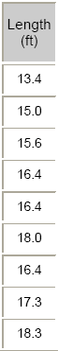
Nominal
OD
(inch)
3.50

3.75

4.75

6.25

6.50

6.62

6.75

8.00

9.00

Metric
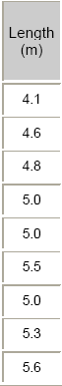
Nominal
OD
(mm)

89

95

121

159

165

168

171

203

229

Length
(ft)

13.4

15.0

15.6

16.4

16.4

18.0

16.4

17.3

18.3

Length
(m)

4.1

4.6

4.8

5.0

5.0

5.5

5.0

5.3

5.6
Thru
Bore
(inch)
1.25

1.19

2.25

2.25

2.25

2.75

2.75

2.81

2.81

Thru
Bore
(mm)

31.8

30.2

57.2

57.2

57.2

69.9

69.9

71.4

71.4
Approx.
Weight
(lbs)
300

415

600

1,250

1,300

1,400

1,400

2,100

3,000

Approx.
Weight
(kg)

135

190

270

570

590

635

635

955

1360
Pump
Open
Area (in²)
6.0

6.0

11.80

19.6

19.6

21.7

23.8

30.7

41.3

Pump
Open
Area
(mm²)
3900

3900

7600

12 700

12 700

14 000

15 300

19 800

26 600
Torsional
Yield
(ft lbs)
7200

9500

15,000

42,000

46,000

47,000

41,000

82,000

149,000

Torsional
Yield
(N·m)

9800

12 900

20 300

57 000

62 400

63 700

55 600

111 200

202 000
Nominal Up
Latch
Setting (lbs)
35,000

35,000

40,000

90,000

90,000

90,000

95,000

100,000

110,000

Nominal Up
Latch
Setting
(daN)
15 600

15 600

17 800

40 000

40 000

40 000

42 300

44 500

48 900
Nominal
Down Latch
Setting (lbs)
15,000

15,000

18,000

40,000

40,000

40,000

42,000

45,000

50,000

Nominal
Down Latch
Setting (lbs)

6700

6700

8000

17 800

17 800

17 800

18 700

20 000

22 200
Max Pull
During
Delay (lbs)
50,000

65,000

85,000

160,000

160,000

170,000

190,000

240,000

240,000

Max Pull
During
Delay
(daN)
22 200

28 900

37 800

71 200

71 200

75 600

84 500

106 700

106 700
Tensile
Yield
(lbs)
190,000

192,000

352,000

803,000

803,000

747,000

860,500

950,000

1,419,000

Tensile
Yield
(daN)

84 500

85 400

156 600

357 200

357 200

332 300

382 800

422 600

631 200

Specifications are based on as new condition and are subject to change without notice.

Wenzel Downhole Tools Ltd.

Oklahom

