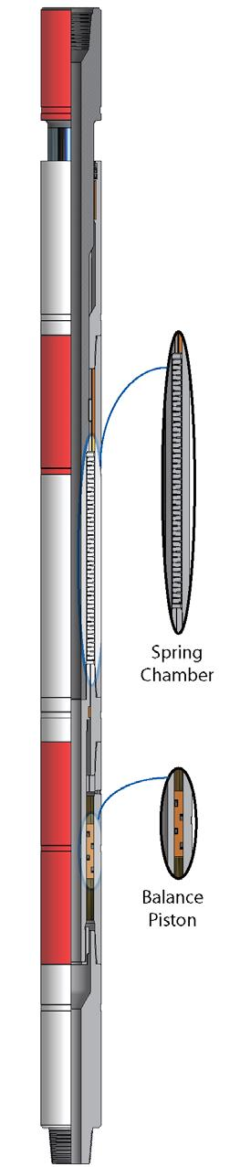
“Trendsetters in Downhole Drilling Solutions”

WZL

Shock Tool

Description

The Wenzel Downhole Shock Tool effectively reduces impact loading on the bit to
extend bit life and reduce bit trips. By isolating axial bit vibrations from the drill string,
the shock tool will reduce lateral and torsional drill string vibrations, and related fatigue
damage or failure of the rotary connections. The shock tool allows optimum bit speed
to be used under rough drilling conditions, increasing the rate of penetration.

Features / Benefits

❍ Does not use temperature-sensitive elastomers for shock absorption, therefore
is suitable for use in temperatures to 275°F (135°C), with optional seals
available for temperatures up to 450°F (230°C)
❍ Reliable Belleville disc springs provide optimum load/deflection characteristics
to maintain consistent contact between bit and formation, effectively reducing
impact loading to extend bit life
❍ Isolates bit induced vibrations from the drill string
❍ Fully oil-sealed and lubricated for extended service life
❍ Pressure balanced to eliminate the effect of downhole hydrostatic pressure
❍ Low friction torsional drive permits free vertical movement
❍ Well-stabilized, with internal three-point lateral support to minimize deflection
❍ Reduces wear and tear on rig and equipment, and fatigue failures on drill
collars and drill pipe
❍ Automatically compensates for pump open force

Operation

• For maximum effectiveness, the shock tool should be positioned immediately
above the bit.
• With a packed bottom hole assembly, the shock tool may be located a
minimum of two drill collar lengths above the top stabilizer, however bit
protection will be reduced due to the greater un-sprung mass below the tool.
• Automatic compensation of pump open effect makes the shock tool effective
with any combination of bit weight or circulating pressure.

Shock Tool Specifications
Imperial

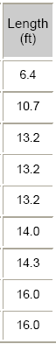
Nominal
OD
(inch)
3.50

4.75

6.25

6.50

6.75

8.00

9.00

9.50

10.00

Metric
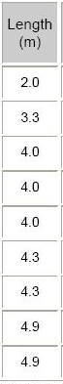
Nominal
OD
(mm)
89

121

159

165

171

203

229

241

254

Length
(ft)

6.4

10.7

13.2

13.2

13.2

14.0

14.3

16.0

16.0

Length
(m)

2.0

3.3

4.0

4.0

4.0

4.3

4.3

4.9

4.9

Thru Bore
(inch)

1.00

1.50

2.25

2.25

2.75

2.75

3.00

3.00

3.00

Thru Bore
(mm)

25

38

57

57

70

70

76

76

76
Approx.
Weight
(lbs)
170

490

1000

1050

1100

1750

2200

2850

3100

App.
Weight
(kg)
80

220

460

480

500

800

1000

1300

1400
Torsional
Yield
(ft lbs)
9000

16,800

40,200

40,500

50,500

92,000

115,500

152,500

154,000

Torsional
Yield
(N·m)
13 000

23 000

56 000

56 000

70 000

128 000

160 000

212 000

214 000

Tensile Yield
(lbs)

205,000

480,000

895,000

895,000

875,000

1,301,000

1,404,000

1,100,000

1,100,000

Tensile Yield
(daN)

91 200

213 500

398 100

398 100

389 200

578 700

624 500

489 300

489 300

Specifications are based on as new condition and are subject to change without notice.

Wenzel Downhole Tools Ltd.

